WEB Quest 108 Digital convergence

Items highlighted in yellow are tasks for you to complete
Items in Blue italics are help tips
You should find more links on the Internet to help you answer questions
Questions are numbered and may be highlighted = answer where you see this Answer

Introductory notes…
Through digitization nearly everything can be converted to numbers and processed by a computer. Every type of media: photographs, sounds, music, books, movies, letters and newspapers can become digital and therefore distributed and consumed in ways never before possible. The process by which these media are digitized and delivered across computer networks is called digital convergence.
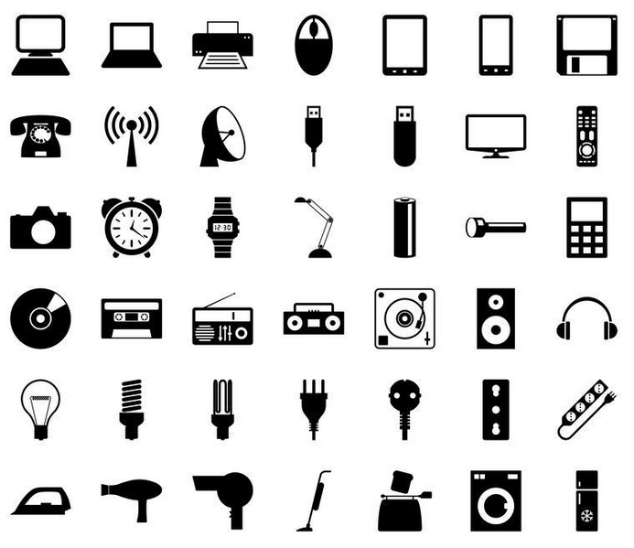
Digital convergence influences how society communicates, learns, works and plays. The advantage of media that has been digitized is its flexibility. Digital files can be compressed, (like an MP3 music file), manipulated (like photographs) or made interactive (like the menu on a movie DVD).
Digital convergence is driven by large commercial companies who see the future in multipurpose personal digital devices, such as portable media players. Digital convergence has been described as ‘the art of bringing computing and consumers together’.

Advantages of digital convergence
The first advantage of digital convergence is that digital products are very cheap to make.
Consider the cost of producing an online digital book compared to a printed copy available in the book store. The printed book requires the production of paper from forest products. The pages of the book need to be ‘set out’ ready for the printing press, along with any artwork. The printing process requires specialised equipment and trained operators. Printing and binding a book can take several days before it is ready for distribution to bookstores. The distribution requires transport networks and vehicles to deliver the books to the store, as well as an ordering system.
In the digital world, there is only one copy of the book produced. It doesn’t need to be printed or bound. It is placed in a database on a computer network and from there anyone with access to the network can obtain a copy of the book. The cost of printing and distribution is paid for by the consumer. From the time the author finishes the book to the time the consumer reads it is negligible. In fact, some authors are releasing their latest books one chapter at a time over the web. The ability to consume a digital product is almost immediate.
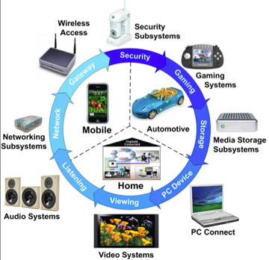
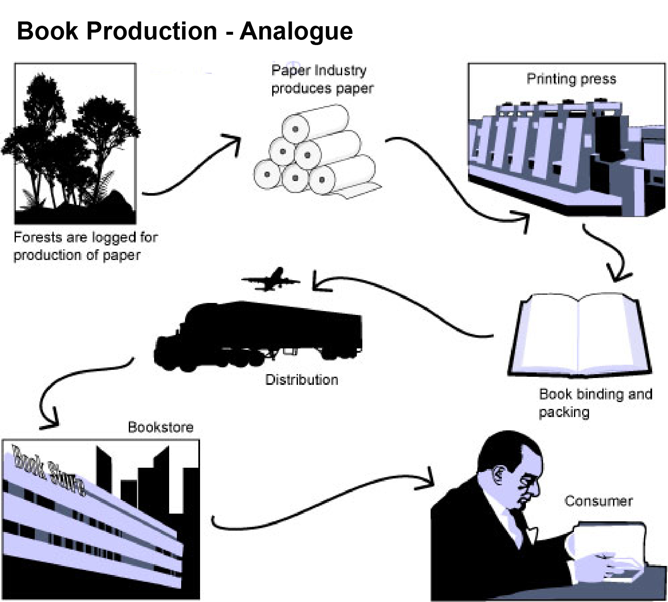

The second advantage of digital convergence is quality. Digital versions of products don’t degrade with use or reproduction. | 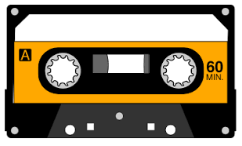

Before the introduction of the Compact Disc, music was distributed on tape cassettes. The cassettes used a ribbon of tape wound on spools in the same way as a video tape. The equipment used to play the tape contributed to its degradation. The more times the tape was played the worse the quality became.

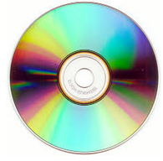 | With digital recording came optical playback using lasers. The use of a laser to read digital information on a disc meant that the surface of the disc was not damaged by continued use. Add to this the fact that every piece of information stored on the disc is read and processed exactly as it was recorded, the quality of digital storage is clear.
Computers and software can refine the digital signal further. Using special programmes to remove noise, means that digital recording and playback provides a higher quality product. Given the right hardware and software, digital copies of music and images can be so good, they are indistinguishable from the originals.
The third advantage is portability and transmission.

With advancements in communication networks and the materials used to make wires and cables, digital files can be transmitted at the speed of light. The extensive use of fibre optic technology in communication has made it possible to transmit digital information between any two places almost instantly. Where wires can’t be used, radio waves can broadcast digital signals. In the future, almost every device will be communicating within a computer network.

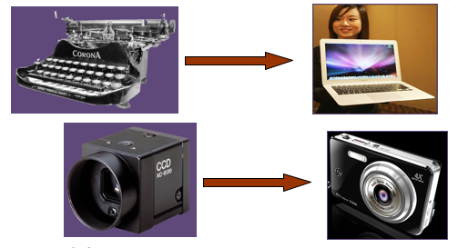

End of notes Web Quest Starts here…
Save as yourname_wbq119.doc

Consider each of the following questions.
Use a new word processing application to answer each question. (You may need to use reference books or the Internet to assist you).
1. Make a list of analogue devices and products that you know have been replaced by digital alternatives.

Analogue | Types | Digital alternatives | Types | Notes

2. Discuss at least one item of technology that has been affected by digital convergence.
http://www.digitalistmag.com/innovation/2014/08/06/impact-of-technology-convergence-01257734

3. How do you think digital convergence will affect you? Comment on how these changes will affect the way you work, learn and have fun.
https://brainly.in/question/424567

4. What effects do you think digital convergence will have on newspapers, television and music?
http://www.nytimes.com/2013/10/15/business/media/peering-into-the-future-of-media.html?pagewanted=all

5. List some disadvantages of digital convergence. Comment on the cost of upgrading computer hardware and software to meet the demands of new products.
https://zeusandreadis.wordpress.com/2011/11/08/technological-convergence-and-its-benefits-on-the-everyday-life/

